* References
  + <https://www.youtube.com/watch?v=D8vT7G0WATM> (What is Scrum)
  + <https://www.youtube.com/watch?v=wPvG9NZNUa4> (Sprint Planning)
  + <https://www.tsmithcreative.com/blog/2017/what-are-story-points/> (What are story Points)
  + <https://www.youtube.com/watch?v=CStypsb3GKI> (Working Agreement)
* Working Agreement
  + Sprints are 1 week long
    - Team demo and retro each Thursday from 3-4
  + Company demo every 3 weeks - next July 6 2018
  + Two teams
    - 1 team of 3
    - 1 team of 4
  + TDD all code
  + Communication?
    - Focus Periods?
  + Boards
    - Jira
    - Physical
      * Daily stand-ups
      * As 1 group
      * Redbins
  + Retrospectives?
  + Roles
    - Developer
    - Team Lead / Scrum Master / Development Manager
* Planning
  + Project Explanation
  + Estimations
* Work Items
  + ~~Password Protect Pdf using an ID number (1)~~
    - Aspose.Pdf .Net SDK for this
    - Load File
    - Get Password
      * ID Number
    - Set Password on File
    - Save File
  + Embed QR code into Pdf (3/2)
    - Aspose.Barcode cloud for this
      * I already have an abstraction to use
    - Write into PDF(2)
      * Load File
      * Create QR Code
        + Write string
        + Make sure it unique
      * Attach to File
      * Save File
    - ~~Read from PDF(1)~~
      * Load File
      * Extract QR Code
        + Verify QR Code
      * Extract string from QR Code
  + Pre-populate form (2)
    - Aspose.Pdf .Net SDK for this
    - Write to pdf & Mark as readonly
    - Task
      * Fetch / Load file
        + File system
      * Get Fields to Prepopulate
      * Populate Fields
      * Mark Fields as Read-only
      * Save Prepopulated form
    - Caveats
      * Use f1040.pdf to populate and mark as read-only fields 76b and 76d to focus on single value cells.

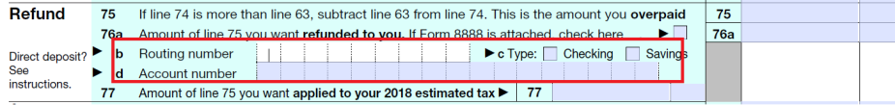

* + Add swagger to project for demo
    - <https://petstore.swagger.io/?_ga=2.22299581.726126681.1529906503-2076919977.1529581832>
* Action Items
  + GitLab repository
  + SAHL to purchase Acrobat DC Pro
  + SAHL to purchase Aspose.Pdf .Net SDK